**Free Lessons Available On:**

**Monday, May 23   
& Monday, May 30 2016**

**6 PM on the Lawn in Washington Park Denver Colorado**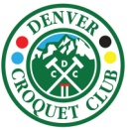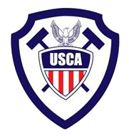

The Denver Croquet Club is hosting for the United States Croquet Association the

**2016 National 9 Wicket Championship Tournament June 17th to June 19th, 2016.**

Come to lessons on May 23rd & May 30th to learn how to play in advance of the tournament! The Denver Croquet Club, located in Denver’s historic Washington Park will be the host of the tournament. **However**, this tournament will not be played on the manicured lawn in Washington Park. This will be **BACKYARD** croquet played on the grass just like your back yard with your family and friends. Today, the real **9 wicket sport of croquet** is somewhat different from that of your past memories. Big difference, there are real rules, not just the ones Uncle Fred made up. A typical game lasts about 45 min and the game keeps moving with a 45 second player time limit

Questions, contact Tournament Director, Matt Baird, (918 760 7226) [mbaird1@att.net](mailto:mbaird1@att.net),